Engineering Data Analysis Level 4
Complete Practice Question Set
Dataset Description
You are given pump performance test data containing:
- Test No
- Flow Rate (L/min)
- Pressure (bar)
- Power Input (kW)
- Output Power (kW)
- Temperature (°C)
- Operating Hours
- Maintenance Cost ($)
Your task is to analyze the performance of the pump system using Microsoft Excel.

Section 1: Descriptive Statistics
Q1. Flow Rate Statistical Analysis
Calculate the following parameters for Flow Rate:
- Mean Flow Rate
- Median Flow Rate
- Minimum Flow Rate
- Maximum Flow Rate
- Range of Flow Rate
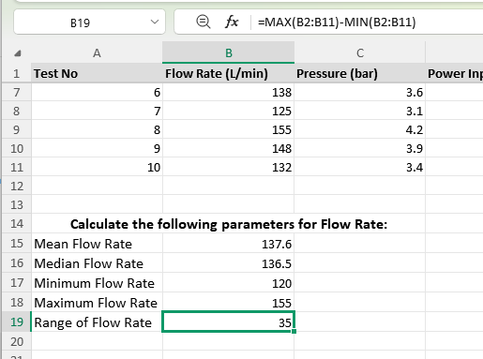

Q2. Power Performance Statistics
Calculate descriptive statistics for:
Power Input
Find:
- Average Power Input
- Maximum Power Input
- Minimum Power Input
Output Power
Find:
- Average Output Power
- Maximum Output Power
- Minimum Output Power
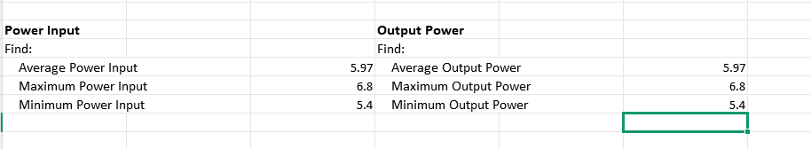

Q3. Create Operating Parameter Summary Table
Create a table:
Parameter | Average | Minimum | Maximum | Range
Flow Rate
Pressure
Power Input
Output Power
Temperature
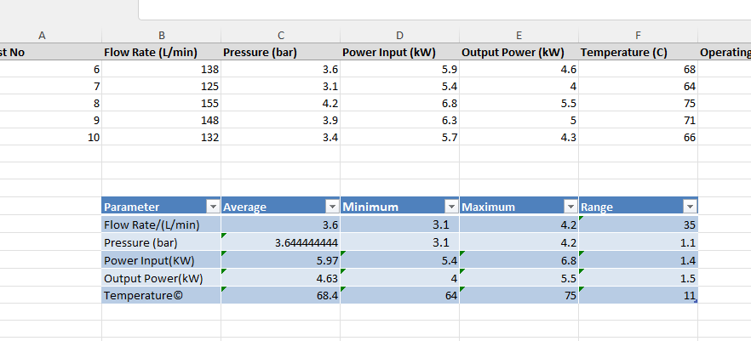
Section 2: Variability Analysis
Q4. Temperature Stability Analysis
Calculate:
- Standard deviation of Temperature
Question:
Is the operating temperature stable or highly variable?
Ans: The operating temperature is reasonably stable, with moderate variation. It is not highly variable based on these 10 observations.

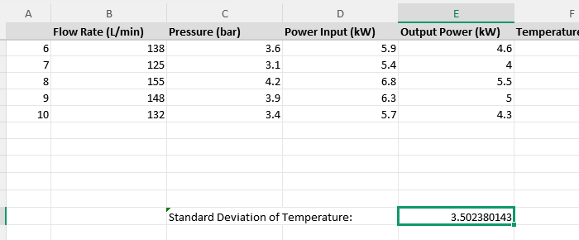

Q5. Power Variation Analysis
Calculate:
- Variance of Power Input
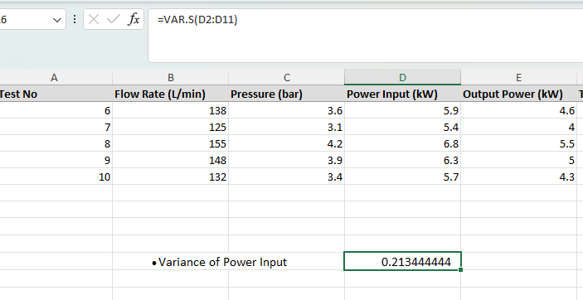

Q6. Compare Parameter Variation
Compare:
- Temperature Standard Deviation
- Power Input Variance
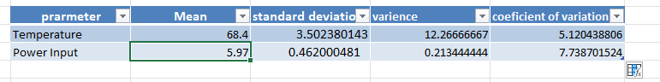
Question:
Which parameter has higher variation?

Answer:
Power Input has higher relative variation because its CV is 7.74%, compared with 5.12% for Temperature.

Explain why variation monitoring is important in engineering systems.
Answer:
Variation monitoring is important because it helps engineers:
Detect abnormal operation
Unusual variation may indicate a developing equipment problem.
Maintain system stability
Monitoring variation helps ensure operating parameters remain within acceptable limits.
Improve reliability
Large or unexpected variations can indicate conditions that may reduce equipment reliability.
Support preventive maintenance
Changes in operating data can help identify when maintenance may be required.
Improve quality and efficiency
Stable operating conditions generally make engineering processes more predictable.

Section 3: Percentile Analysis
Q7. Flow Rate Distribution Analysis
Calculate:
- 25th Percentile
- 50th Percentile
- 75th Percentile
- 90th Percentile
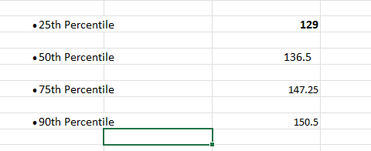
Q8. Identify High Performance Operating Range
Using percentile values:
Determine:
- Normal operating range
- High performance rang
Top 10% flow rate range.
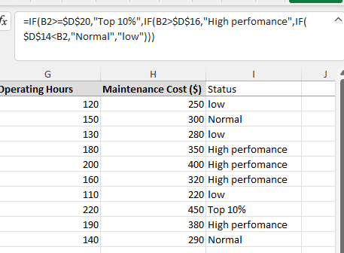

Section 4: Correlation Analysis
Q9. Flow Rate vs Output Power Relationship
Calculate correlation between:
Flow Rate and Output Power
Formula:
=CORREL()
Questions:
- Is the relationship positive or negative?
- Is the relationship strong or weak?
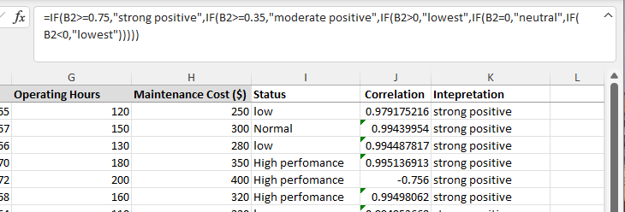
Q10. Temperature vs Power Input Relationship
Calculate correlation between:
Temperature and Power Input
Interpret the result.
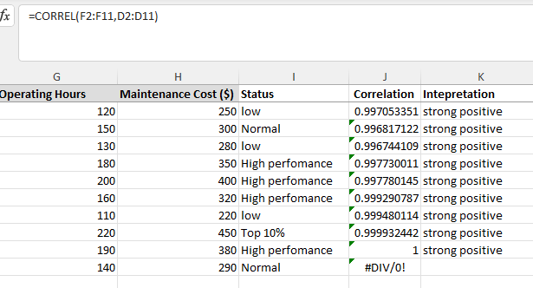
Q11. Maintenance Dependency Analysis
Calculate correlation between:
Operating Hours and Maintenance Cost
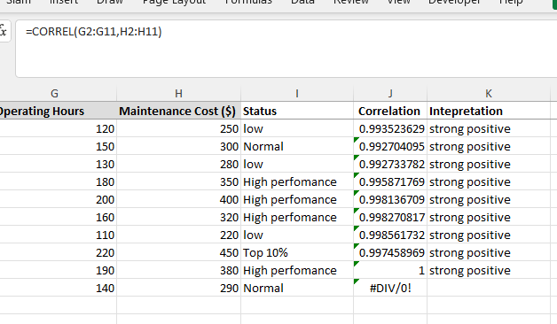
Question:
Does longer operation increase maintenance cost?
Yes, longer operation is associated with higher maintenance cost. The correlation coefficient is approximately 0.9935, indicating a very strong positive relationship between operating hours and maintenance cost.
Section 5: Regression Analysis
Q12. Build Prediction Model
Create a regression model:
Independent Variable:
Flow Rate
Dependent Variable:
Output Power
Find:
- Regression equation
- Slope
- Intercept
- R² value

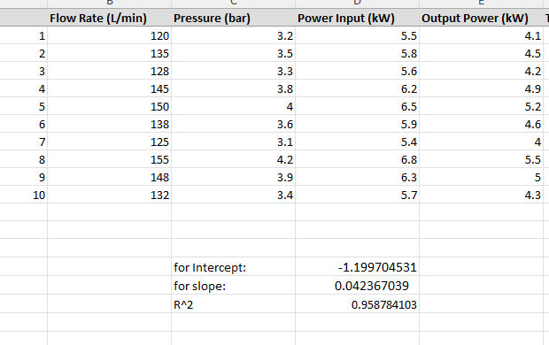
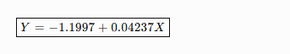

Q13. Engineering Prediction
Using regression equation:
Predict output power when:
Flow Rate = 160 L/min
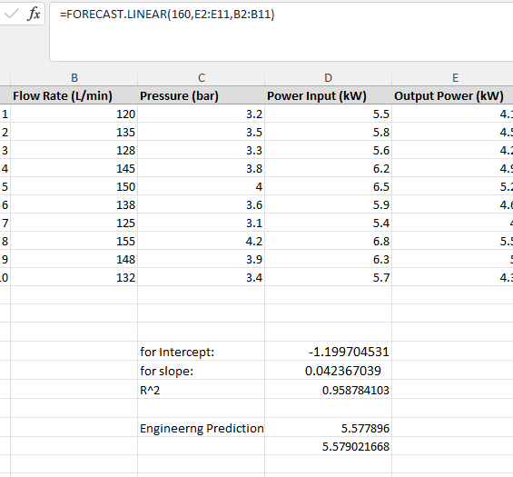
Section 6: Trend and Forecasting Analysis
Q14. Temperature Trend Analysis
Create a line chart:
X-axis:
Test Number
Y-axis:
Temperature

Is temperature increasing, decreasing, or stable?
Temperature shows a slight increasing trend with fluctuations. It is not steadily increasing because the temperature rises and falls between tests.Q15. Power Consumption Trend
Create chart:
Test Number vs Power Input
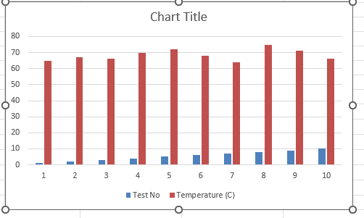
Identify:
- Peak power condition
- Lowest power condition
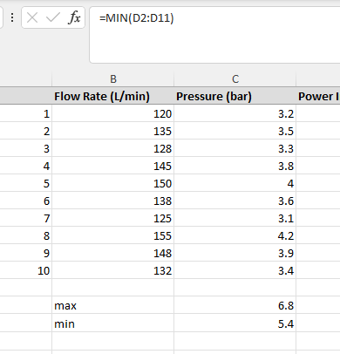
Q16. Moving Average Analysis
Calculate:
3-test moving average of Flow Rate
Create chart:
- Actual Flow Rate
- Moving Average
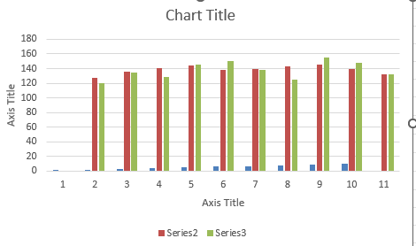
Question:
Does moving average show a clear performance trend?
The 3-test moving average smooths the short-term fluctuations and shows a generally upward performance trend, although individual flow-rate values fluctuate significantly.
Q17. Forecast Future Performance
Use:
Excel Forecast Sheet
Predict:
Test No. 11 Flow Rate
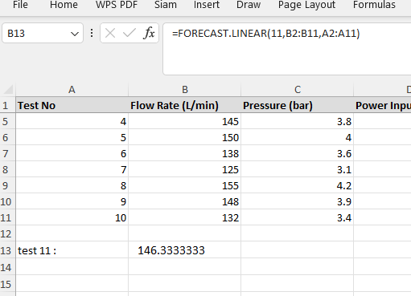
Compare:
Forecast value vs previous trend.
The forecasted Flow Rate for Test 11 is approximately 146.33 L/min. This is higher than Test 10's actual value of 132 L/min, and it is consistent with the overall upward trend observed in the previous tests.

Section 8: Engineering Calculations
Q21. Pump Efficiency Calculation
Calculate efficiency:
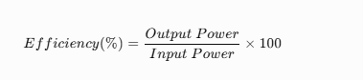
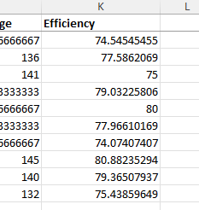
Q22. Energy Consumption Calculation
Calculate:
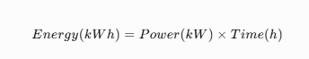
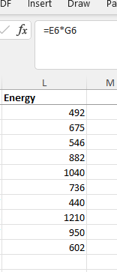

Q23. Maintenance Cost Analysis
Calculate:
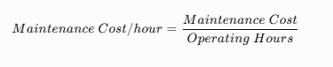
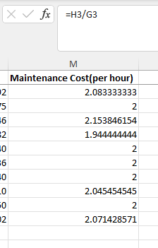
Q24. Unit Conversion
Convert:
Flow Rate
L/min → m³/hr
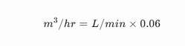
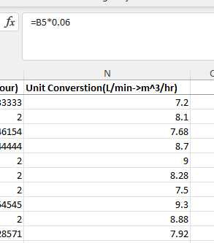
Pressure
bar → Pascal
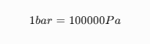
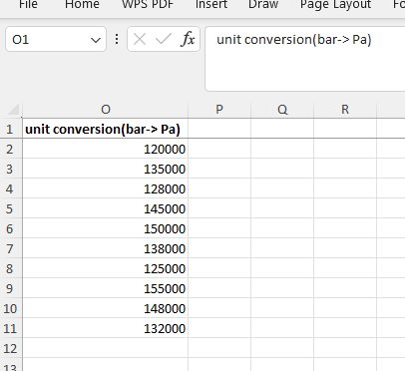
Section 9: Tolerance Analysis
Q27. Tolerance Checking
Design Pressure:
4 bar
Tolerance:
±5%
Determine:
Which measurements are acceptable?
